TWO NODE CLUSTER.

I have only 4GB RAM. So I have created a two node cluster.

First Cluster: SNN, NN, JT

Second cluster: DN, TT

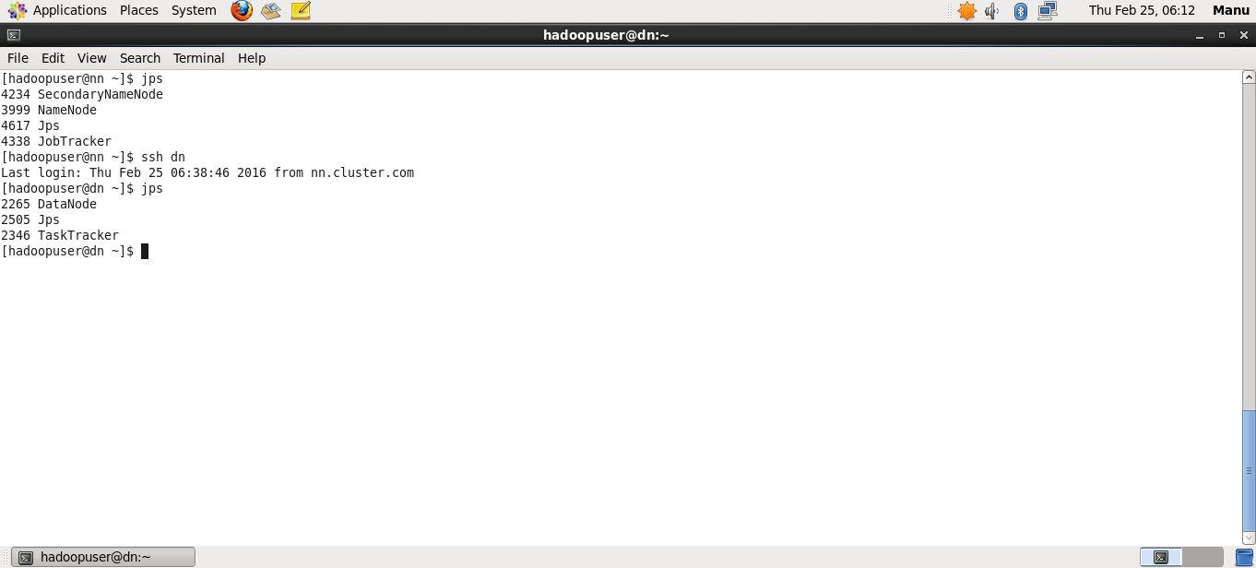

First Cluster : NN,JT,TT,DN,SNN

Second Cluster: DN,TT

